**SHRI VAISHNAV VIDHYAPEETH VISHVA VIDHYALAYA**

Shri Vaishnav Institute of Information Technology

Department Of Computer Science and Engineering

(Session: - Jan-jun 2020)



**PROJECT REPORT FILE**

Advanced Java Programming

Subject Name :- _______________________________________________

BTCS - 409

Subject Code :- _______________________________________________

Submitted To :- Submitted By :-

Mr. Sachin Chirgaiya

Atharv Dayma

_________________ _________________

Enrollment No. :-

18100BTCSICS03001

_________________

|  |  |  |
| --- | --- | --- |
| VISION | : | “To be renowned for excellence in Computer Science & Engineering” |
| MISSION | : | “To impart quality education, meeting the latest industry requirements, futuristic research & developments in Computer Science & Engineering” |

**Objective**

A software product which provides solution for baby health, baby food, baby tips, baby products, baby names, parenting etc. Here, user can view baby names, baby names by religion, baby tips, baby food and baby product. Admin can add and delete baby names.

**Users of the System**

1. Admin
2. Users

**Functional Requirements**

**1. Admin**

1. Can login and logout.
2. Can add baby names.
3. Can view baby names.
4. Can delete baby names.
5. Can add new pages.

**2. Users**

1. Can view baby names.
2. Can view baby tips.
3. Can view baby food.
4. Can view baby products.

**Non-Functional Requirements**

1. Secure access of confidential data (user?s details). SSL can be used.
2. 24 X 7 availability
3. Browser testing and support for IE, NN, Mozila, and Firefox
4. Reports exportable in .XLS, .PDF
5. Create a detailed UML diagram (Component, Sequence, Class) for the system and its sub-components

**User Interface Priorities**

1. Professional look and feel
2. Use of AJAX atleast with all registration forms and with every search option and at the id of each searched result with onmouseover event.

**Tools to be used**

1. Use any IDE to develop the project. It may be Myeclipse / Eclipse / Netbeanse.
2. Oracle 10g for the database.
3. Server: Apache Tomcat/JBoss/Glassfish/Weblogic/Websphere.

**Front End and Back End**

1. **Front End:** JSP, JDBC, Javascript, AJAX
2. **Back End:** Oracle10g

**How project works?**

To get detail explanation about project download the document file. It includes snapshots with explanation.

**Software Requirement to run this project**

1. You need to install an IDE Eclipse / Myeclipse / Netbeans.
2. MySQL database. (Here, we are not using any username and password for MySQL database).

**How to run this project**

1) Import the SQL file in MySQL (located in Web-Content directory)

2) Paste mysql-connector.jar file inside lib directory.

3) Import the project on the Eclipse IDE and run it.

**Password for Admin**

Username is **admin** and password is **admin123**.

**Welcome Page (Screenshots)**

**Home page**

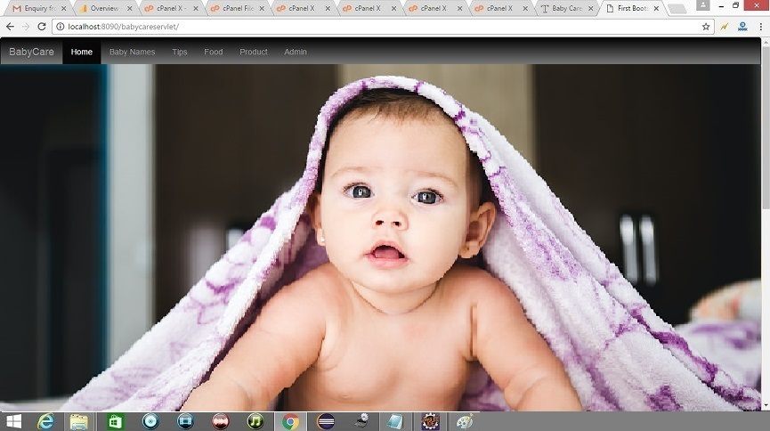

**ADMIN LOGIN**

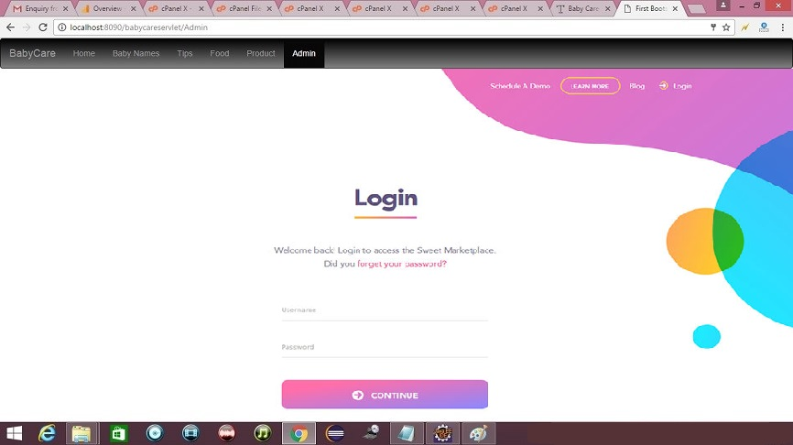

**Baby Name page**

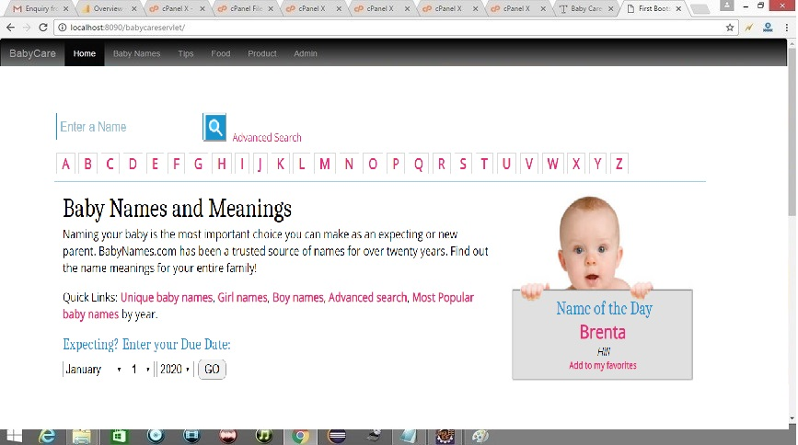

**Baby product page**

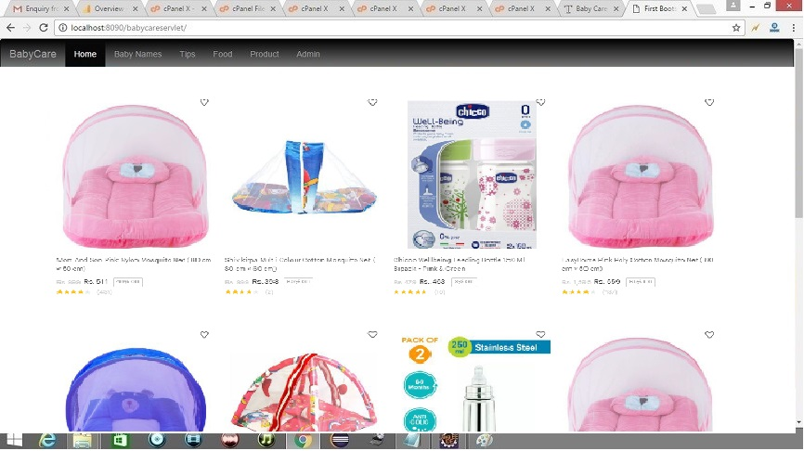

**Baby food page**

